
Chain Beyond Theorem – Platform Comparisons

Objective:
Software Used:

- Laptop/PC
- Internet Connection
- Web Browser (Chrome / Brave)
- Official Documentation and Whitepapers of:
- Ethereum
- Binance Smart Chain (BSC)
- Polygon
- Solana
- Avalanche

To analyze and compare various blockchain platforms beyond Ethereum, focusing on their architectural design, consensus mechanisms, transaction throughput, scalability, and practical real-world applications.

Theory/Concept:

Different blockchain platforms present unique trade-offs in terms of speed, decentralization, security, and scalability. While Ethereum remains the most widely adopted smart contract platform, several alternative networks have emerged to overcome its challenges, such as high gas fees and limited throughput. Various consensus mechanisms power these platforms — Ethereum employs Proof of Stake (PoS), Binance Smart Chain (BSC) uses Proof of Staked Authority (PoSA), Solana combines Proof of History (PoH) with PoS, Avalanche implements the Avalanche Consensus protocol, and Polkadot operates on Nominated Proof of
Stake (NPoS). In terms of transaction speed, Solana and Avalanche provide near-instant confirmations
Within sub-seconds to a few seconds, whereas Ethereum and BSC offer moderate speeds with enhanced security. Regarding scalability, solutions like Polygon extend Ethereum’s capabilities through Layer 2
scaling, while platforms such as Avalanche and Solana inherently support thousands of transactions per
second (TPS), ensuring higher efficiency and throughput.
Procedure:
- Research Scope: Examine major blockchain platforms — Ethereum, Binance Smart Chain (BSC), Polygon, Solana, Avalanche, and Polkadot.
- Consensus Mechanisms: Study the underlying consensus algorithms, transaction speeds, and scalability features using official documentation.
- Development Environments: Compare EVM-compatible and non-EVM platforms to understand differences in smart contract deployment and execution.
- Smart Contract Languages: Analyze the programming languages supported by each platform, such as Solidity, Rust, and Move.
- Blockchain Explorers: Use tools like Etherscan, Solscan, and BSCScan to observe real-time transaction speeds, gas fees, and on-chain activity.
- Performance Metrics: Record and compare key data points — average block time, transaction cost, and transactions per second (TPS).
- Interoperability: Evaluate cross-chain bridges and interoperability tools that enable communication between different blockchain networks.
- • Data Presentation: Summarize all research findings in a detailed comparison table for clear visualization and analysis.

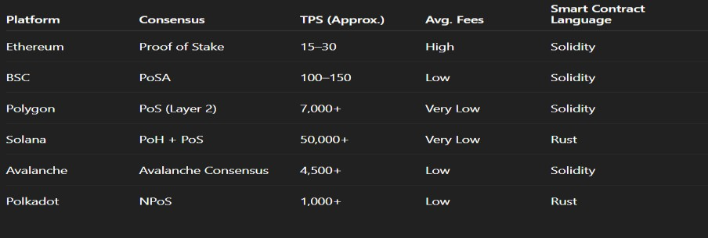
Observation Table:

